1. **Agenda**:Graphical user interface, text, application

   Description automatically generated
2. First parse the response body from JSON into a JS Object.  
   
3. Graphical user interface, application

   Description automatically generated  
   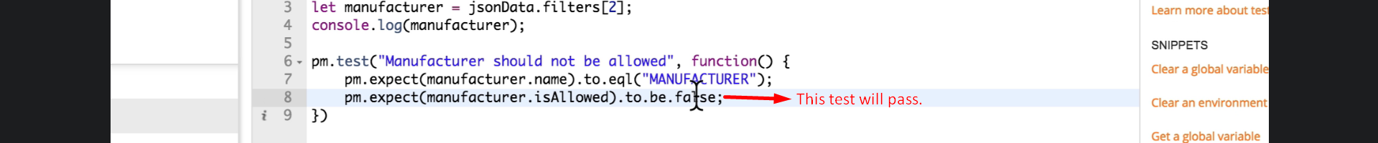
4. A picture containing application

   Description automatically generated